Report of the degree of decentralization in Z-cash

1. GitHub metrics

- contributor commit activity (number of contributors - 490, number of active contributors in 2023 - 11, percentage of commits from top contributors - 34%),

- number of pull requests - 90,

- releases - 69 (latest - 23.06.2023),

- 9 branches,

- 2000 forks

2. Operational metrics

- allocation of z-cash: 80% mining reward, 12% founding companies

- Zcash wasn’t pre-mined and not ICO funded. Zcash had a group of closed investors who funded $1 million to kickstart the development. The investors were promised with a 10% reward of the total supply in an incremental way over the first 4-year period as so called “Founder’s Reward”.

- dispersion: average whale value ZEC 21,847.81 ($3,353,343.94)

- profit mechanism - mining

- Market cap - $489,273,696

- Total supply 16,328,269 ZEC

- Max. supply 21,000,000 ZEC

3. Blockchain metrics

- cost of 51% attack - $3,437 per hour

- proof mechanism - Zero-Knowledge Proving System

- Hashrate: 4.19 PH/s

- total number of nodes: 5006

- 15 mining pools, 5 of pools located in USA, pool viabtc.com solved 55% of last 1000 blocks

4. Exchanges

* Zcash is traded on 56 exchanges across 113 trading pairs

Also the amount of nodes is enough to support Z-cash decentralization, however the fact that only one mining pool is responsible for solving half of mined blocks, undermining full decentralization.

Conclusion: Z-cash is fairly decentralized, although it has become less decentralized as it has scaled.

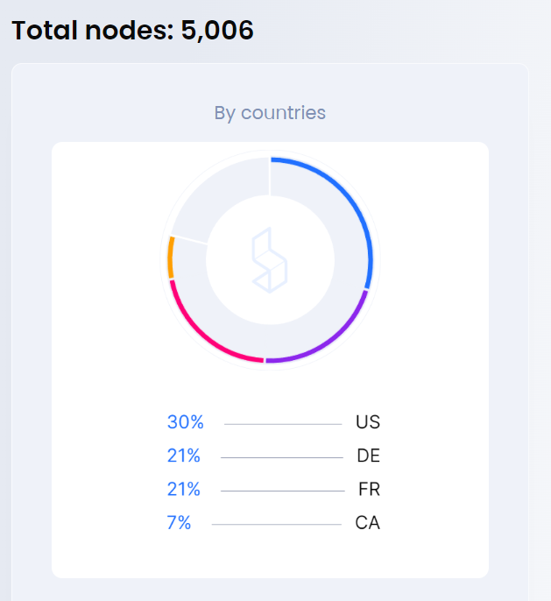

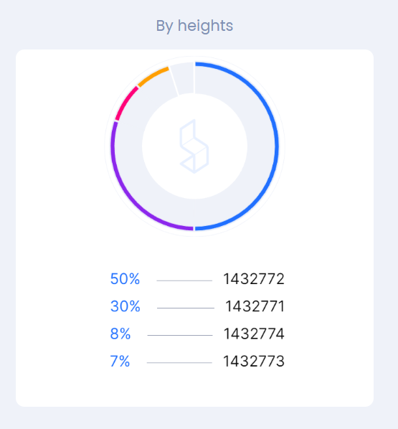

Zcash hashrate is a calculated numerical value that specifies an estimate of how many hashes are being generated by Zcash miners trying to solve the current Zcash block or any given block.

Zcash hashrate is represented in Hashes per Second or H/s.

The global Zcash network hashrate is a calculated value and is measured in hashes per second (H/s). The calculation uses the current mining difficulty and the average Zcash block time between mined blocks versus the defined block time as variables to determine the global Zcash network hashrate.